AI FitTrack
AI-Powered Personalized Fitness Tracking and Recommendation System

INTRODUCTION
• Project Title: AI FitTrack
• Team ID: SWTID-2026-5541
• Team Leader: Ramya S & Mail ID:ramyaclg15@gmail.com
• Team Members:
- Abima K & Mail ID:abimaabima390@gmail.com
- Tharani S & Mail ID:tharaniselvam648@gmail.com
- Sharamila U & Mail ID:uttrakumar1617@gmail.com
- Saranya R & Mail ID:saranyaraghu@gmail.com

ABSTRACT
AI FitTrack is an AI-powered fitness tracking and recommendation system developed to help users manage their workout activities, maintain workout history, and receive personalized fitness guidance. The system combines workout management with Artificial Intelligence to provide recommendations according to the user's age, fitness goal, and experience level

The application is developed using Node.js, Express.js, MongoDB, Mongoose, and Google Gemini AI. The backend follows the Model–View–Controller (MVC) architecture, which provides a modular and maintainable structure. RESTful APIs are used for user authentication, workout management, workout searching, AI-based recommendations, and fitness insights.

The system provides secure authentication using JSON Web Tokens (JWT), while user passwords are encrypted using bcrypt.js before being stored in the database. Authenticated users can create, view, update, delete, and search their workout records. The AI module uses Google Gemini to generate personalized workout plans, exercise suggestions, training tips, safety recommendations, and motivational guidance.

AI FitTrack reduces the need for manual workout record keeping and provides users with a centralized platform for monitoring their fitness activities. The system can also be extended in the future with nutrition tracking, BMI calculation, wearable device integration, workout reminders, and fitness analytics.

Background of the Project
Many fitness applications provide workout tracking features, but users may still need to manually decide which exercises are appropriate for their fitness level and goals.
The AI FitTrack system combines two important functions:
- Workout tracking
- AI-assisted fitness guidance
The system provides a centralized platform where users can store workout records and obtain personalized recommendations. According to the project design, Google Gemini processes user information and generates recommendations such as weekly workout plans, suggested exercises, training tips, and safety recommendations.

Problem Statement
Traditional workout tracking methods have several limitations:
- Difficulty maintaining a centralized workout record.
- Manual entry may result in inaccurate or incomplete history.
- Searching previous workout records can be time-consuming.
- Users may not know which workouts are suitable for their experience level.
- Manual calculation of workout statistics requires additional effort.
- Traditional systems may not provide personalized recommendations.
- Users may lack meaningful insights about their workout performance.
Therefore, a secure and intelligent system is required to manage workout records and provide personalized fitness guidance.

Aim of the Project
The main aim of AI FitTrack is to develop a secure and intelligent fitness tracking system that enables users to manage their workout records and receive personalized AI-based fitness recommendations.

Objectives
The major objectives of the project are:
- To provide secure user registration and login.
- To maintain workout records in a centralized database.
- To provide complete CRUD operations for workouts.
- To allow users to search their workout history.
- To protect personal information using authentication mechanisms.
- To integrate Google Gemini AI for personalized workout recommendations.
- To generate fitness insights from workout statistics.
- To provide structured JSON responses through RESTful APIs.
- To develop a modular and maintainable backend architecture.
- To provide a system that can be extended with additional fitness features in the future.

PRE-REQUISITES

Software Requirements
The software requirements are:
Software | Purpose
Windows 10/11, macOS or Linux | Operating System
Node.js | Server-side runtime
npm | Package management
Express.js | REST API development
MongoDB | Database
Mongoose | MongoDB object modeling
Google Gemini AI | AI recommendations
Postman | API testing
Visual Studio Code | Development environment

Hardware Requirements
Component | Requirement
Processor | Intel Core i5 8th Gen or above / equivalent
RAM | Minimum 8 GB
Recommended RAM | 16 GB
Storage | Minimum 1 GB available space

PROJECT ARCHITECTURE
The FitTrack AI follows a layered architecture based on the MVC (Model–View–Controller) design pattern. The application separates routing, business logic, database interaction, middleware, and AI services into independent modules, making the project easier to maintain and scale.
When a client sends an HTTP request, the Express server receives it and forwards it to the corresponding route. Protected routes first pass through the authentication middleware, which validates the JWT token before granting access.
Controllers process validated requests and invoke business logic or AI services as required. Database interactions are handled through Mongoose models, while Google Gemini AI is accessed through a dedicated service layer. Finally, the controller returns a structured JSON response to the client.
This layered approach improves modularity, security, and maintainability while ensuring that each component has a single responsibility.

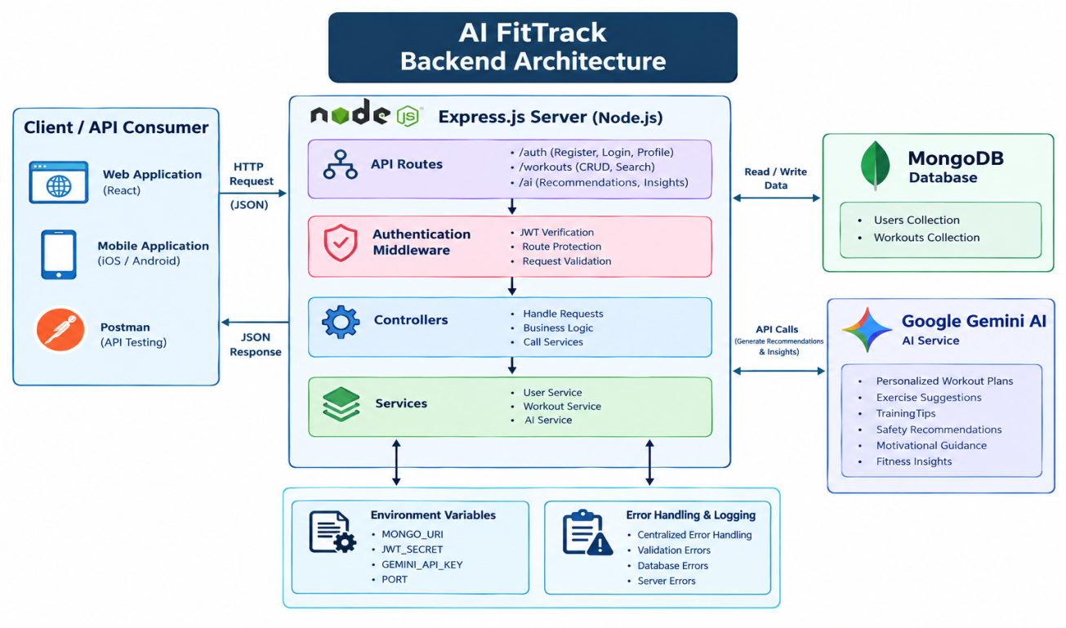
The major components are:
- Client Application
- Express Server
- API Routes
- Authentication Middleware
- Controllers
- Services
- Google Gemini AI Service
- Mongoose Models
- MongoDB Database
The client sends an HTTP request to the Express server. The request is directed to the appropriate route. Protected requests are validated by JWT authentication middleware. Controllers then process the request and communicate with the database or AI service. Finally, the result is returned to the client as a JSON response.

Components Definition

1. Client / API Consumer
The Client Layer is the starting point of the system. It can be a web application, mobile application, or Postman.
Functions:
- Sends HTTP requests to the backend.
- Sends user information and workout data.
- Receives JSON responses.
- Displays workout information and AI recommendations.
- Stores the JWT token after successful login.

2. Express.js Server / Node.js
The Express.js Server acts as the central gateway of the backend. It receives requests from the client and sends them to the appropriate API routes.
Functions:
- Starts the backend server.
- Receives HTTP requests.
- Parses JSON data.
- Enables CORS.
- Connects middleware.
- Routes requests to the correct controller.
- Handles errors.
In simple terms, Express.js controls the movement of requests through the backend.

3. API Routes
Routes define the endpoints through which the client communicates with the backend.The project has three major groups:
Authentication Routes
- Register
- Login
- Profile
Workout Routes
- Add workout
- Get workouts
- Search workouts
- Get workout by ID
- Update workout
- Delete workout
AI Routes
- Workout recommendation
- Fitness insights
Routes decide which controller should handle a particular request.

4. Authentication Middleware
The Authentication Middleware protects the secured APIs.
When a user sends a request to a protected API, the middleware checks whether the user has a valid JWT token.
Process:
Request → JWT Verification → Authorized → Controller
If the token is invalid or missing, the request is rejected.
Functions:
- Reads the Authorization header.
- Extracts the JWT token.
- Verifies the token.
- Identifies the user.
- Allows or rejects the request.
This prevents unauthorized users from accessing personal workout information.

5. Controllers
The Controller Layer contains the main business logic for handling requests.
Controllers receive requests from routes and decide what operation should be performed.
There are three main controllers:
Authentication Controller
- Registration
- Login
- Profile retrieval
Workout Controller
- Create workout
- Retrieve workout
- Update workout
- Delete workout
- Search workout
AI Controller
- Sends requests to the Gemini AI service.
- Receives AI recommendations.
- Sends the result back to the client.

6. Service Layer
The Service Layer contains reusable business logic. It separates important operations from the controllers.
The main services are:
Gemini AI Service
- Prepares AI prompts.
- Sends prompts to Google Gemini.
- Receives AI-generated responses.
- Formats recommendations.
JWT Service
- Creates JWT tokens.
- Configures token expiry.
- Verifies user identity.
Password Service
- Hashes passwords.
- Compares passwords during login.

7. MongoDB Database
MongoDB is the database used to permanently store application information.AI FitTrack mainly contains:
- Users Collection
- Workouts Collection
The Users collection stores user information, while the Workouts collection stores workout records.
Mongoose is used as the connection/ODM layer between Node.js and MongoDB.

8. Google Gemini AI Service
The Google Gemini AI Service is the intelligence component of AI FitTrack.
It receives information such as:
- Age
- Fitness goal
- Experience level
- Workout statistics
It can generate:
- Personalized workout plans
- Exercise suggestions
- Training tips
- Safety recommendations
- Motivational guidance
- Fitness insights
The AI service is accessed through a dedicated service layer rather than being directly embedded inside the controllers.

9. Mongoose Models
Mongoose Models define how information is structured before it is stored in MongoDB.
The project has two main models:
- User Model
- Workout Model
They provide schema definitions, validation, database operations, and the relationship between users and workouts.
For example, every workout contains a user reference that connects it to the corresponding user.

Entity Relationship (ER) Diagram Description
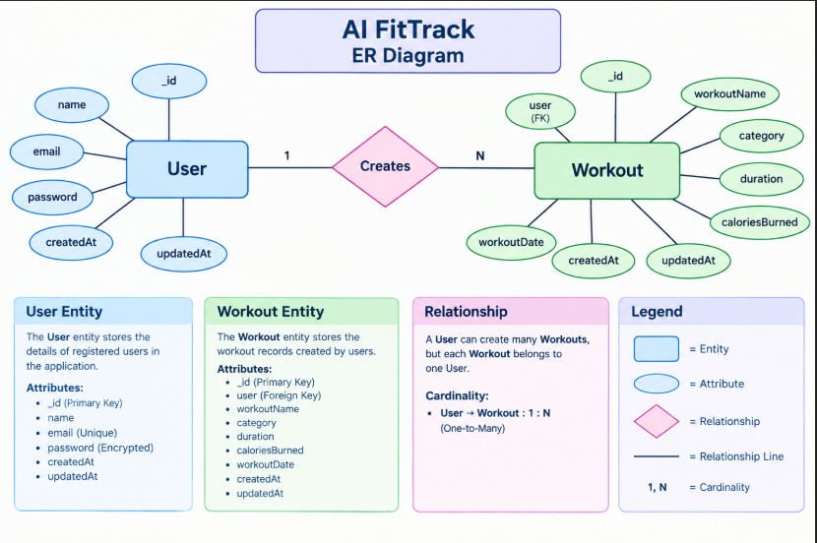

ER Diagram Explanation – AI FitTrack
The attached project document defines two primary entities: User and Workout, connected through a one-to-many relationship.

1. User Entity
The User entity stores the authentication and profile information of registered users.
Attributes:
- _id – Primary Key
- name – Name of the user
- email – Unique email address
- password – Encrypted password
- createdAt – Record creation time
- updatedAt – Last updated time
The email must be unique, the name is mandatory, and the password is encrypted using bcrypt.
2. Workout Entity

The Workout entity stores the workout records created by authenticated users.
Attributes:
- _id – Primary Key
- user – Reference to the User entity
- workoutName – Name of the workout
- category – Type/category of workout
- duration – Workout duration in minutes
- caloriesBurned – Calories burned
- workoutDate – Date of the workout
- createdAt – Record creation time
- updatedAt – Last updated time
The project specifies validation rules such as duration being greater than zero and calories burned being greater than or equal to zero.

3. Relationship – Creates
The relationship between User and Workout is represented by the Creates relationship.
A single User can create multiple Workout records, whereas each Workout belongs to only one User.
Therefore, the relationship is:
User (1) → Creates → (N) Workout
This is called a One-to-Many (1:N) relationship.

4. Foreign Key Relationship
The user attribute in the Workout entity stores the ObjectId of the corresponding User.
For example:
User: Ramya
↓
Workouts:
- Morning Running
- Evening Jogging
- Cycling Session
- Strength Training
This allows every workout record to be associated with the user who created it.

5. ER Diagram Notation
Symbol | Meaning
Rectangle | Entity
Oval | Attribute
Diamond | Relationship
Line | Connection
1 | One
N | Many
USER FLOW

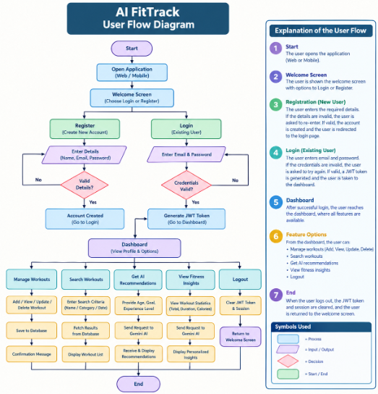

Explanation of the User Flow – AI FitTrack
The User Flow Diagram represents the sequence of actions performed by a user while interacting with the AI FitTrack system. It starts when the user opens the application and ends when the user logs out.

1. Start
The process begins when the user opens the AI FitTrack application through a web or mobile application.
2. Welcome Screen
The user is shown the welcome screen with two main options:
- Register – for a new user.
- Login – for an existing user.

3. User Registration
If the user is new, they select Register and enter:
- Name
- Email
- Password
The system validates the entered information.
- If the details are invalid, the user is asked to enter the information again.
- If the details are valid, a new user account is created.
After registration, the user can proceed to the login page.

4. User Login
An existing user enters their email and password.
The system verifies the credentials.
- If the credentials are incorrect, the user is asked to try again.
- If the credentials are valid, the system generates a JWT token and allows the user to access the dashboard.
JWT authentication is used in the project to protect secured APIs.

5. Dashboard
After successful login, the user reaches the dashboard.
From the dashboard, the user can access the main features of AI FitTrack:
- Manage workouts
- Search workouts
- Get AI workout recommendations
- View AI fitness insights
- Logout

6. Manage Workouts
The user can manage their workout records using CRUD operations.
The available operations are:
- Add a new workout
- View existing workouts
- Update workout information
- Delete unwanted workouts
Each workout is associated with the authenticated user.

7. Search Workouts
The user can search their previous workout records using:
- Workout name
- Workout category
- Workout date
The system retrieves the matching records from the database and displays them to the user.

8. Get AI Recommendations
The user can request a personalized workout recommendation by providing information such as:
- Age
- Fitness goal
- Experience level
The system sends this information to the Google Gemini AI service. Gemini processes the information and generates recommendations such as workout plans, exercise suggestions, training tips, safety recommendations, and motivational guidance.

9. View Fitness Insights
The user can also obtain AI-generated fitness insights based on workout statistics such as:
- Total workouts
- Average workout duration
- Total calories burned
The AI analyzes these values and provides performance analysis, improvement suggestions, motivational advice, and a fitness progress summary.

10. Logout
When the user selects Logout, the active session is cleared and the user is returned to the welcome/login screen.
The User Flow Diagram illustrates the sequence of activities performed by a user in the AI FitTrack system. A new user first registers by providing the required details, while an existing user logs in using email and password. After successful authentication, a JWT token is generated and the user is redirected to the dashboard. From the dashboard, the user can manage workout records, search previous workouts, request AI-powered workout recommendations, and obtain AI-generated fitness insights. Finally, the user can log out, which ends the session and returns the user to the welcome screen.

MVC Architecture Pattern
The FitTrack AI is designed using the Model–View–Controller (MVC) architecture pattern. This architecture separates application logic into independent components, improving code organization, maintainability, and scalability

Model Layer (Data Layer)
The Model Layer defines the structure of the application's data using Mongoose schemas. It communicates directly with MongoDB and performs database operations.
Models in the project include:
- User Model
- Workout Model
Responsibilities:
- Schema Definition
- Data Validation
- CRUD Operations
- Collection Mapping

View Layer (API Interface)
Since AI FitTrack is a backend REST API, there are no traditional UI templates. The View Layer is represented by API consumers such as React applications, mobile applications, or Postman, which interact with the backend through HTTP requests and receive JSON responses.
Responsibilities:
- Send Requests
- Receive JSON Responses
- Display Data
- Handle Client-side Interaction

Controller Layer (Business Logic)
The Controller Layer acts as the intermediary between the View and Model. It processes incoming requests, validates input, invokes services and models, and sends structured JSON responses back to the client.
Responsibilities:
- Request Validation
- Business Logic Execution
- Database Interaction
- AI Service Invocation
- Response Generation
The separation of these three layers ensures loose coupling, simplifies testing, enhances code readability, and makes the application easier to extend with future features.

Project Setup
The project is initialized using Node.js.
The basic setup includes:
AI-FitTrack-API
|
└── server
The Node.js project is initialized using:
npm init -y
Required packages include:
npm install express mongoose dotenv bcryptjs jsonwebtoken cors
Nodemon can be installed as a development dependency:
npm install --save-dev nodemon

Environment Variables:
Sensitive information is stored in the .env file.

PORT=5000
MONGO_URI=mongodb://localhost:27017/aifittrack
JWT_SECRET=your_secret_key
GEMINI_API_KEY=your_google_gemini_api_key
Using environment variables improves security by preventing sensitive information from being exposed in source code.

Backend Components
The backend is divided into independent modules such as:
- Server configuration
- Database configuration
- Authentication
- Workout management
- AI recommendation
- Middleware
- Error handling
This modular structure makes the application easier to maintain and extend.

MongoDB Configuration
AI FitTrack uses MongoDB as its primary NoSQL database for storing user and workout information. MongoDB stores data in collections instead of traditional relational database tables. The project mainly maintains two collections: Users and Workouts.
Mongoose is used as the Object Data Modeling (ODM) library to connect the Node.js application with MongoDB. It provides schema definitions, data validation, database relationships, and simplified CRUD operations.

Database Collections
- Users Collection
Stores registered user information such as name, email, encrypted password, and timestamps.
- Workouts Collection
Stores workout information such as workout name, category, duration, calories burned, workout date, and the associated user.

MongoDB Connection
The database connection is configured in the config/db.js file. This module establishes a connection with the MongoDB server when the application starts.
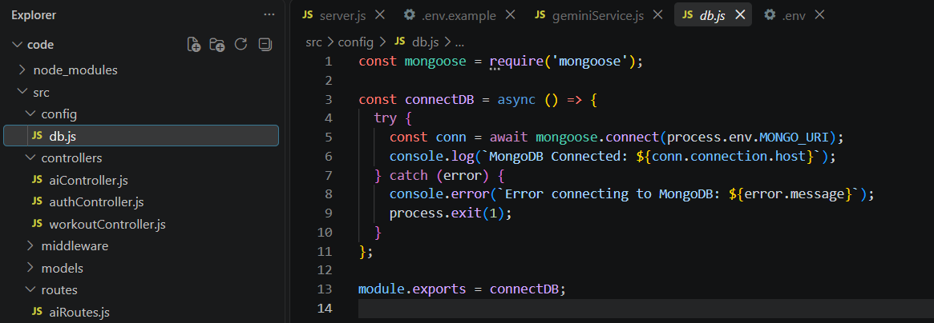
Responsibilities of the database configuration:
- Connect to MongoDB.
- Handle connection errors.
- Display connection status.
- Export the database connection for use by the application.

Advantages
- Flexible schema structure.
- Efficient data retrieval.
- Scalable database architecture.
- Centralized database configuration.
- Simplified database operations using Mongoose.
- Supports relationships between users and their workout records.

Mongoose Schemas
The AI FitTrack backend contains two primary Mongoose schemas: User Schema and Workout Schema. Mongoose schemas define the structure, validation rules, and relationships of the data stored in MongoDB.

User Schema
The User Schema stores authentication and profile information of registered users.
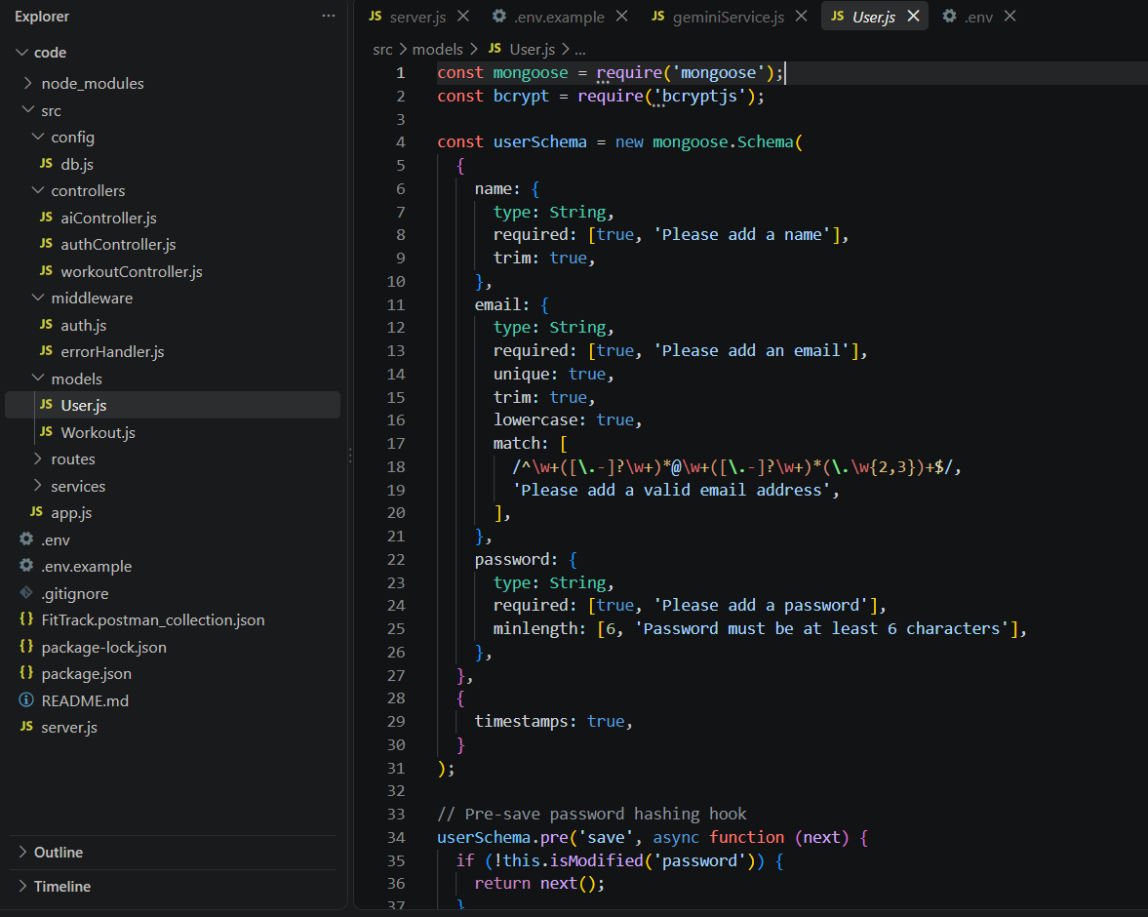

Attributes
Field | Description
_id | Unique identifier of the user
name | Name of the user
email | User's unique email address
password | Encrypted user password
createdAt | Date and time when the record was created
updatedAt | Date and time when the record was last updated

Validation Rules
- Name cannot be empty.
- Email must be unique.
- Password is mandatory.
- Password is encrypted using bcrypt.js before saving.
- Automatic timestamps are enabled.
The User Schema supports secure authentication and JWT-based user authorization.

Workout Schema
The Workout Schema stores workout information created by authenticated users.
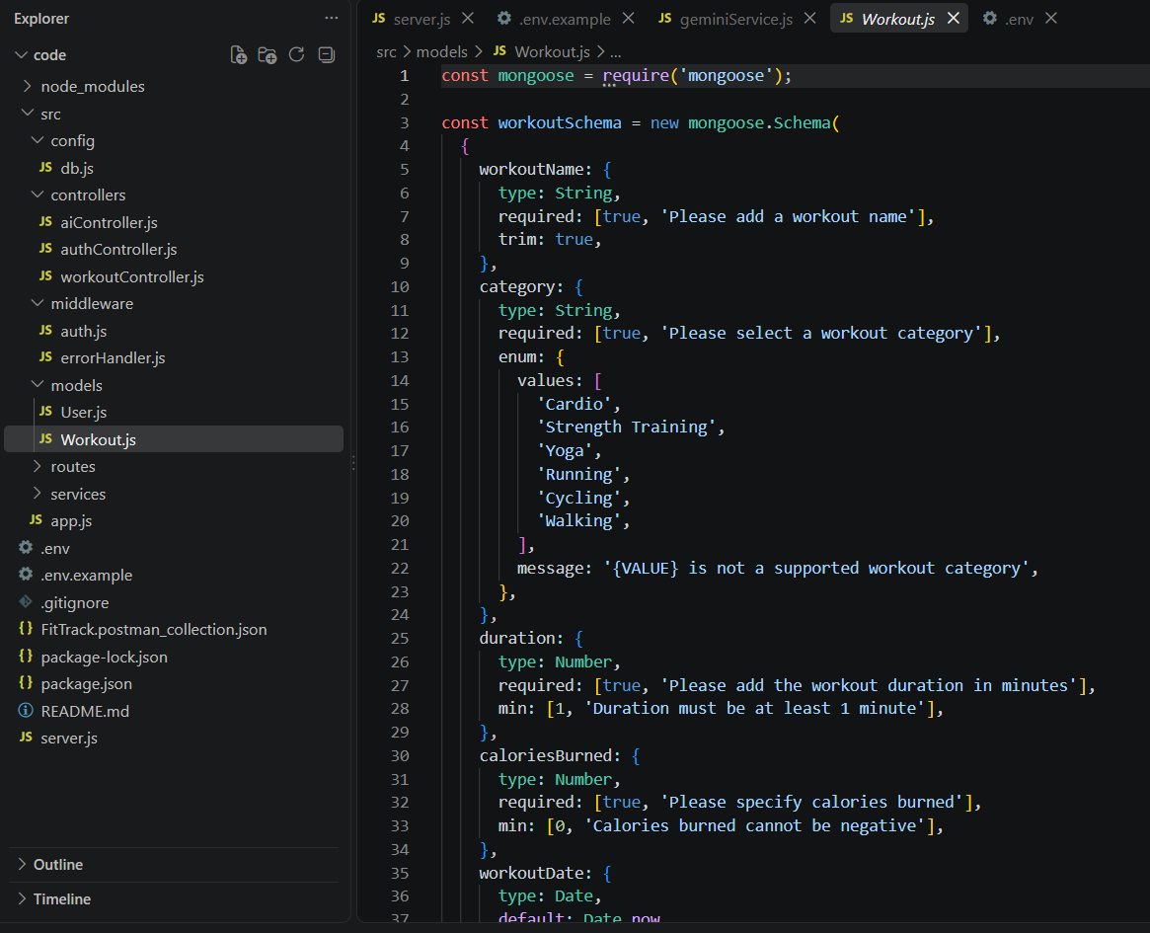

Attributes
Field | Description
_id | Unique identifier of the workout
user | Reference to the associated User
workoutName | Name of the workout
category | Category or type of workout
duration | Workout duration in minutes
caloriesBurned | Number of calories burned
workoutDate | Date of the workout
createdAt | Date and time when the record was created
updatedAt | Date and time when the record was last updated

Validation Rules
- Workout name is mandatory.
- Category is mandatory.
- Duration must be greater than zero.
- Calories burned must be greater than or equal to zero.
- Workout date is required.
- Every workout belongs to one authenticated user.

Relationship Between the Schemas
The user field in the Workout Schema stores a reference to the corresponding User. Therefore:
One User → Many Workouts
This creates a one-to-many (1:N) relationship, where a user can have multiple workout records, but each workout belongs to only one user.
Mongoose schemas provide a structured way to manage AI FitTrack data. The User Schema handles user information and authentication, while the Workout Schema manages workout records and their connection to users. This helps maintain data validation, consistency, and efficient database operations.

Authentication API Testing

Register User

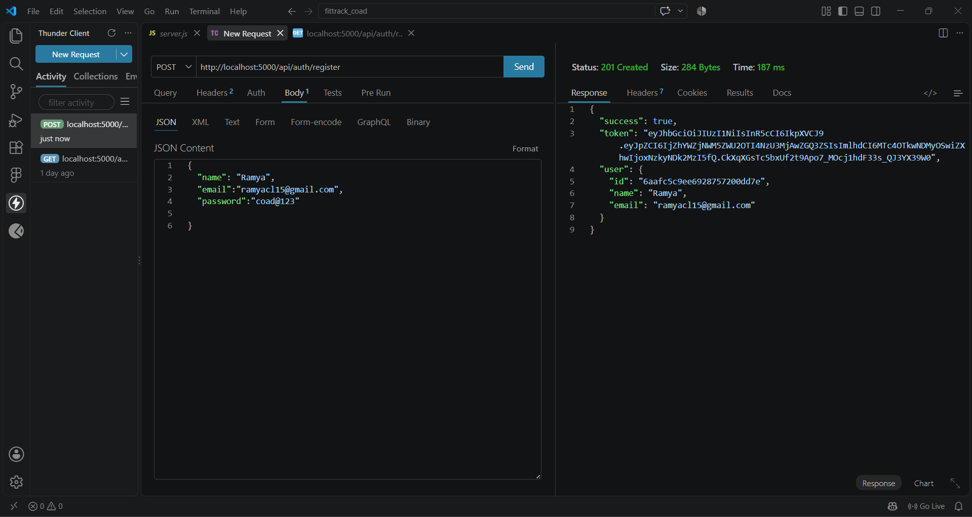

Login User

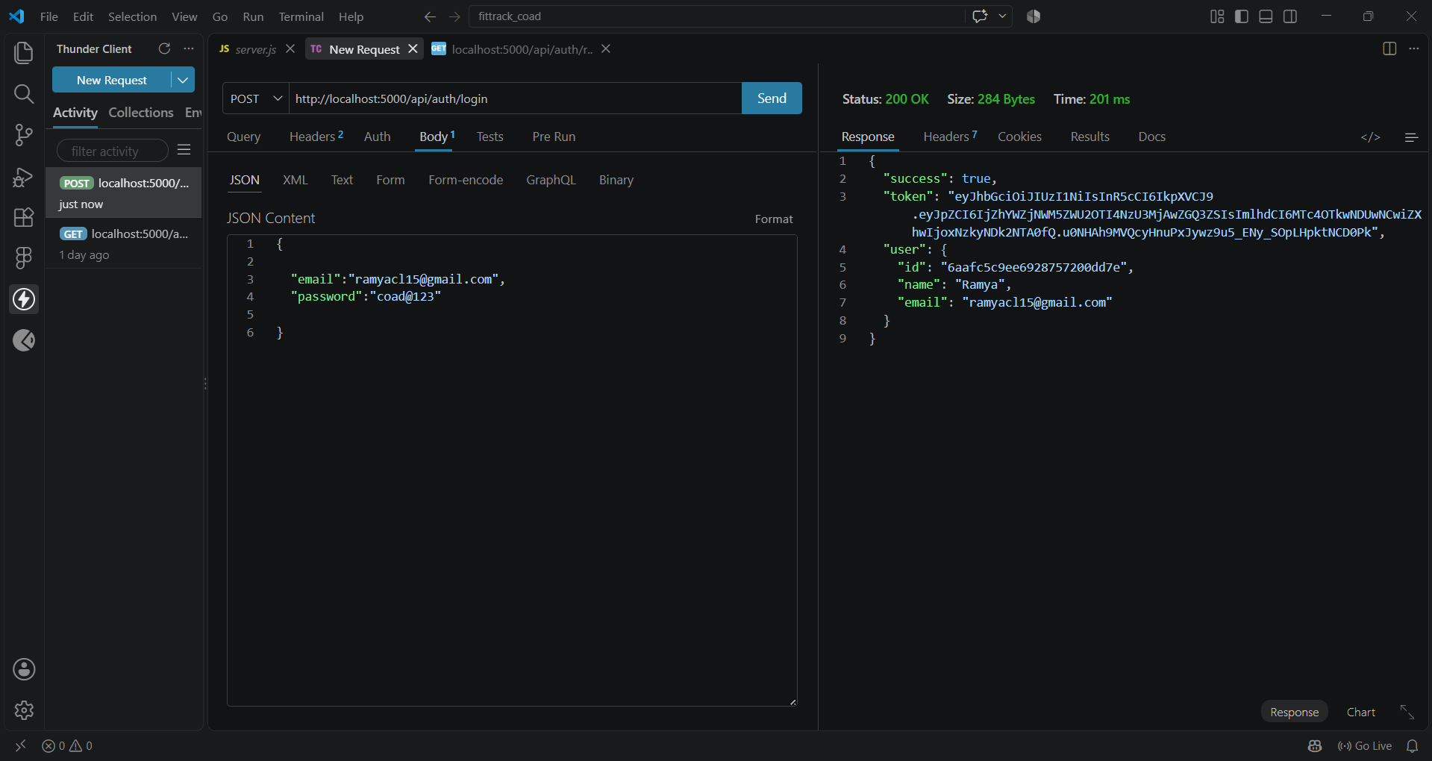

Get Profile

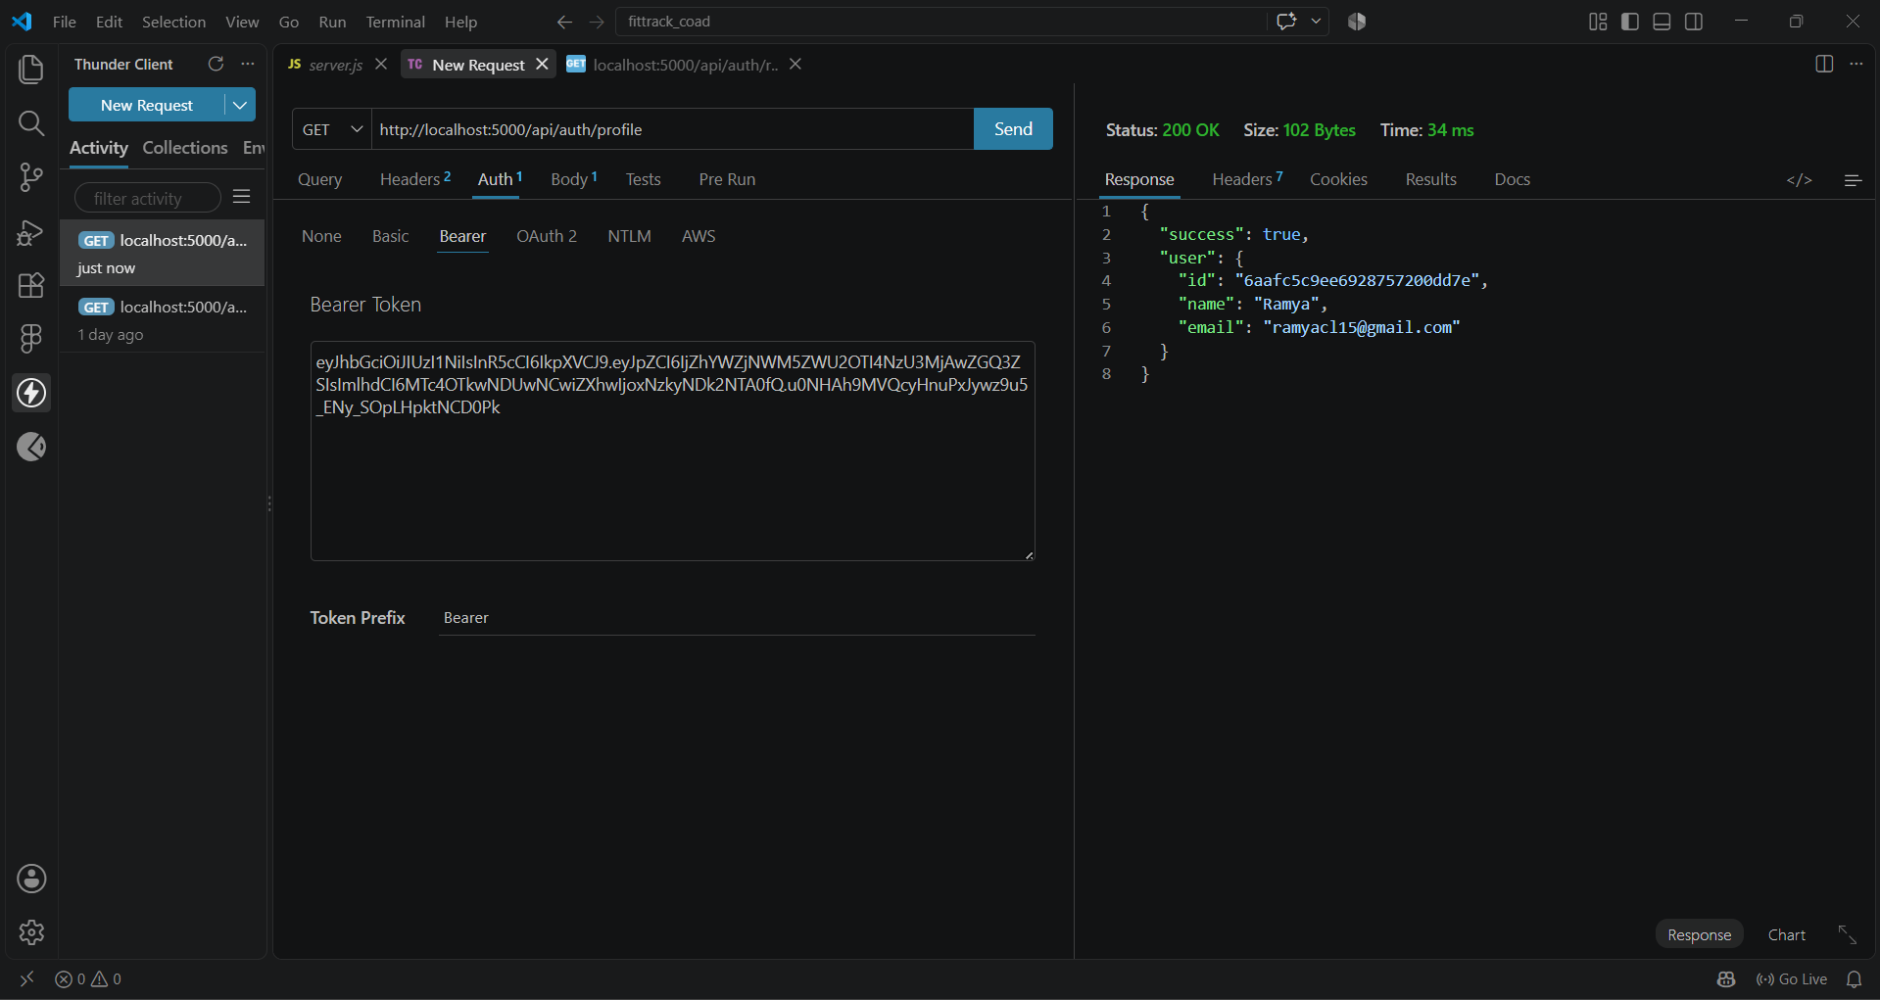

Workout API Testing

Add Workout

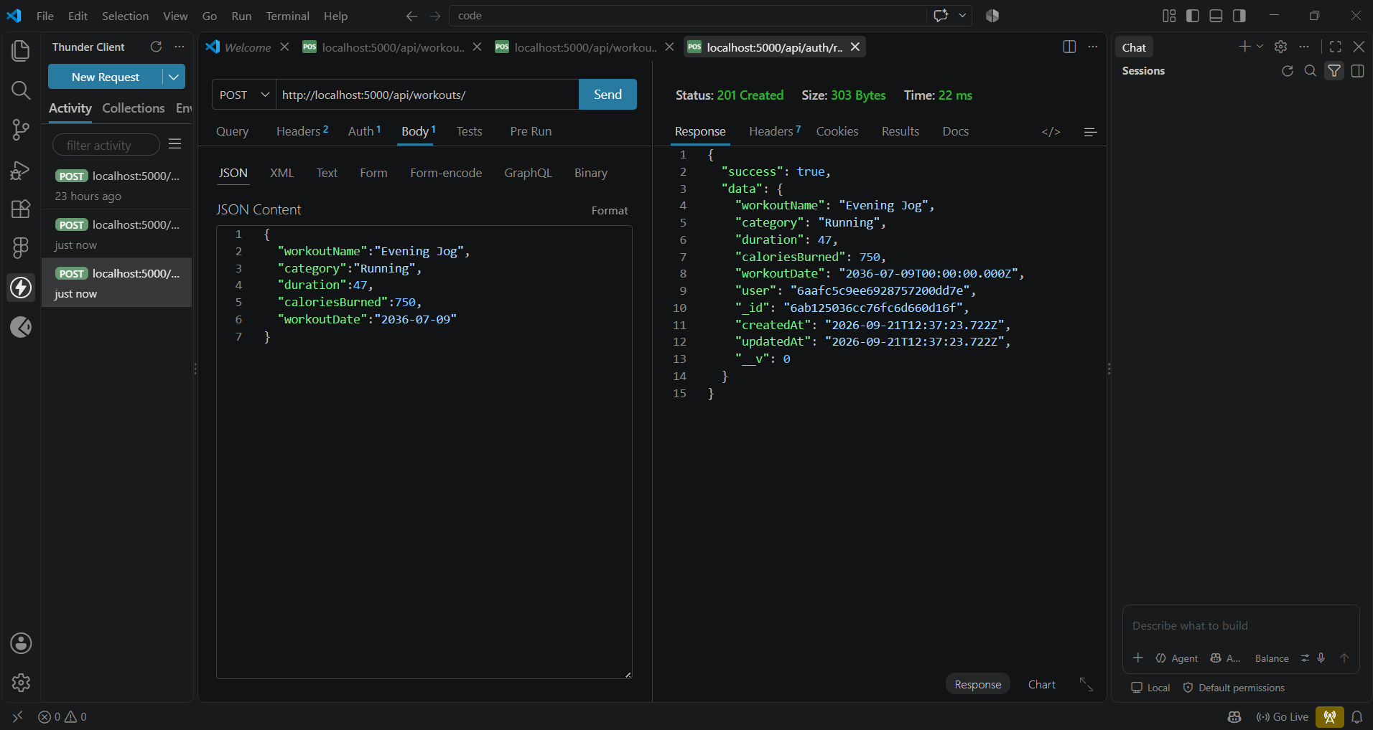

Get All Workouts

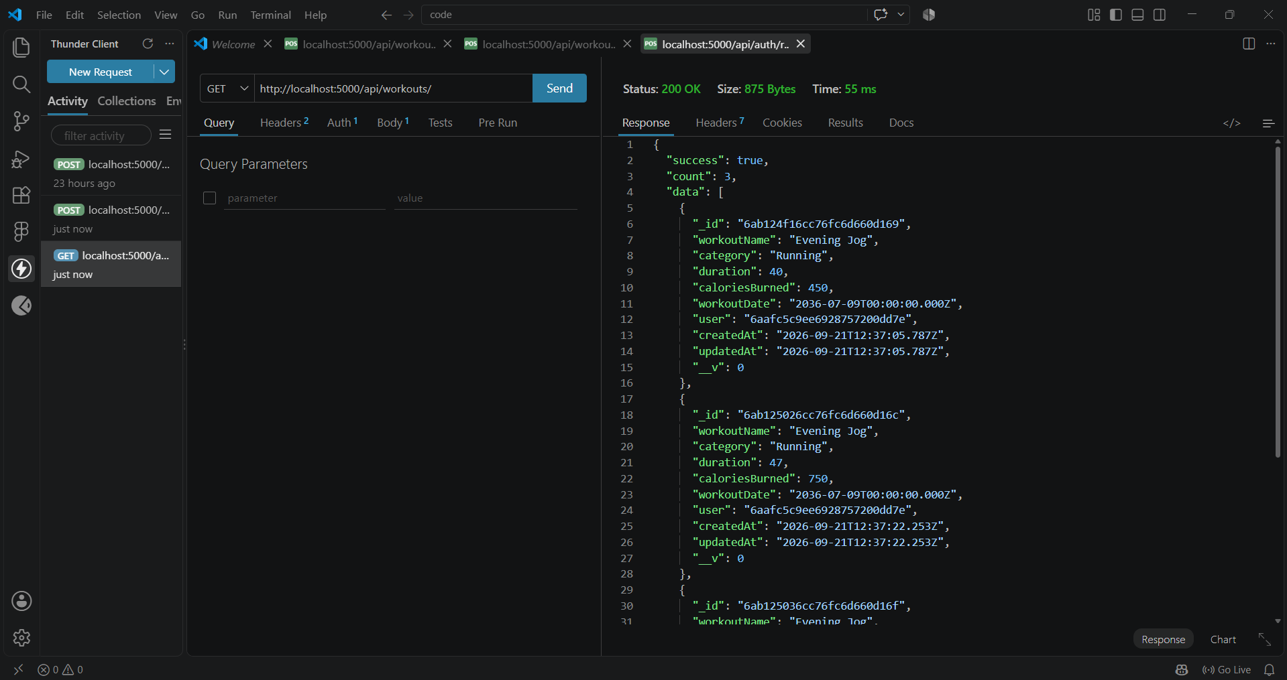

Get Workout By ID

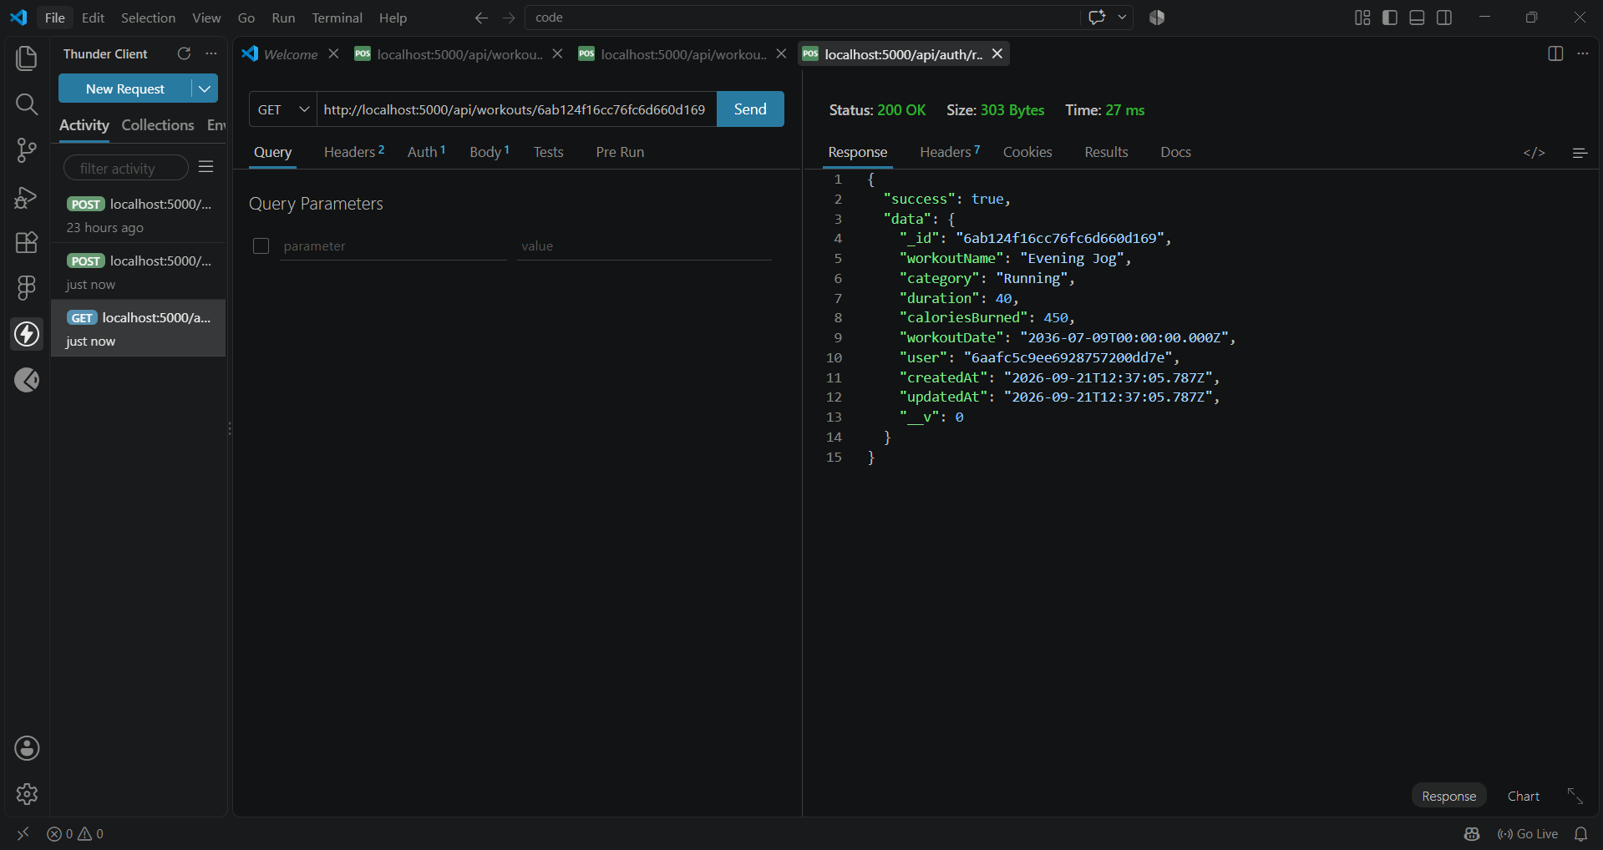

Update Workout

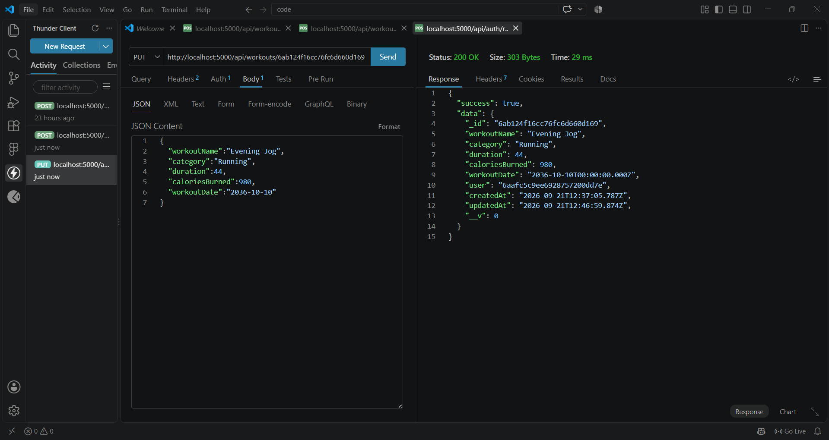

Delete Workout

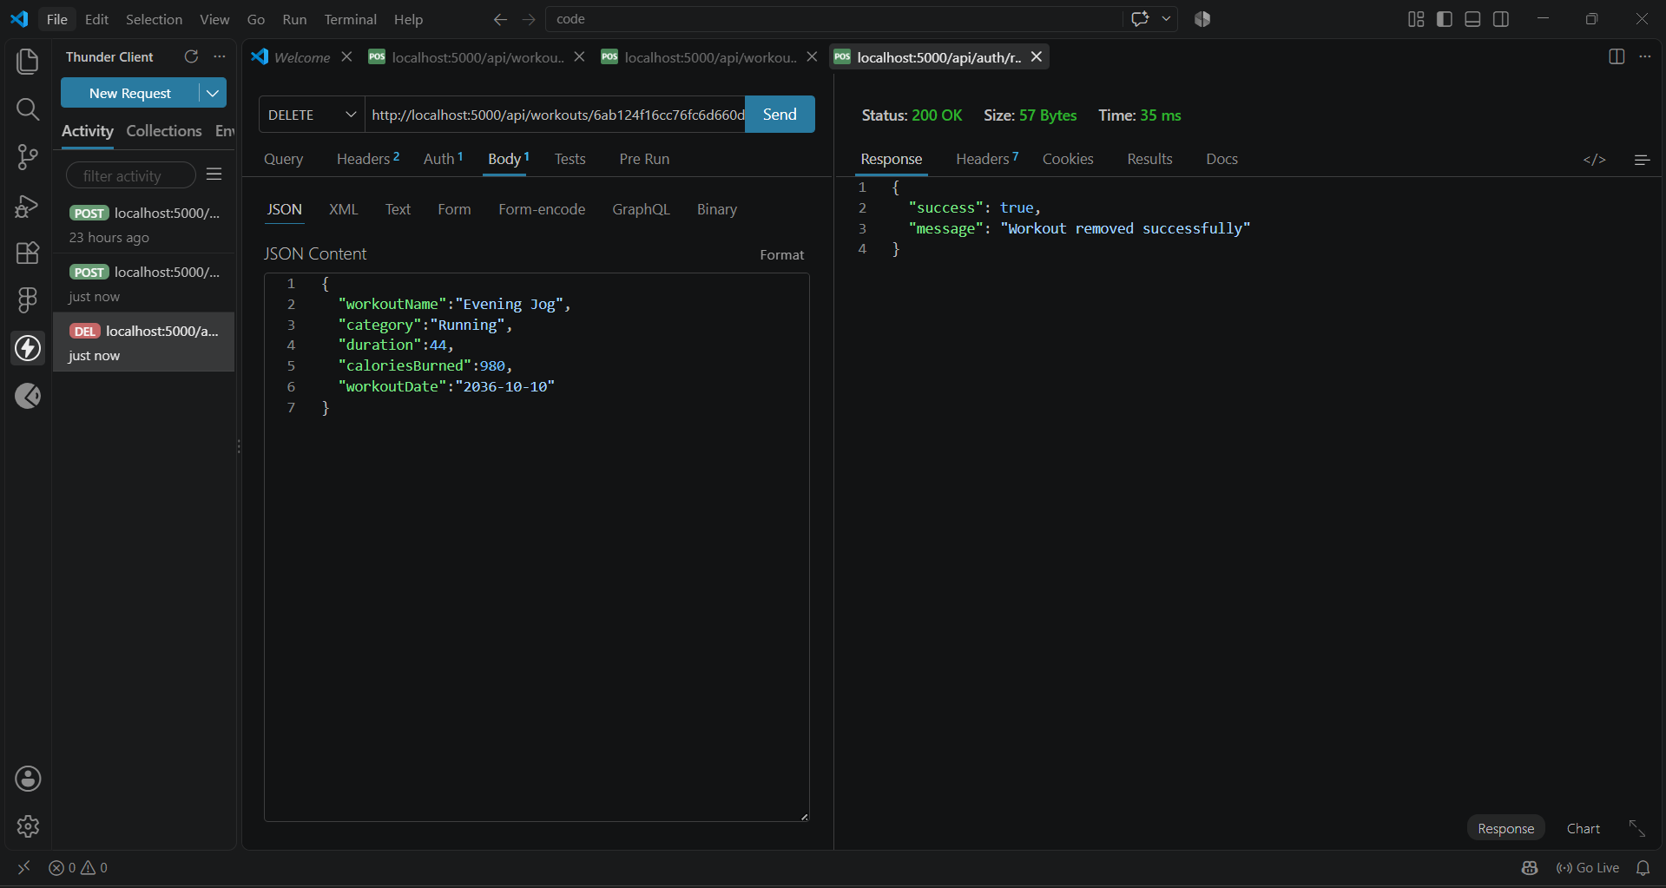

AI API Testing

Workout Recommendation

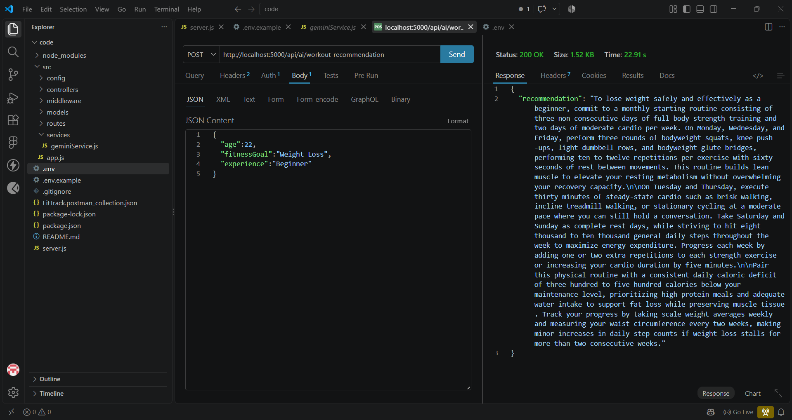

Fitness Insights

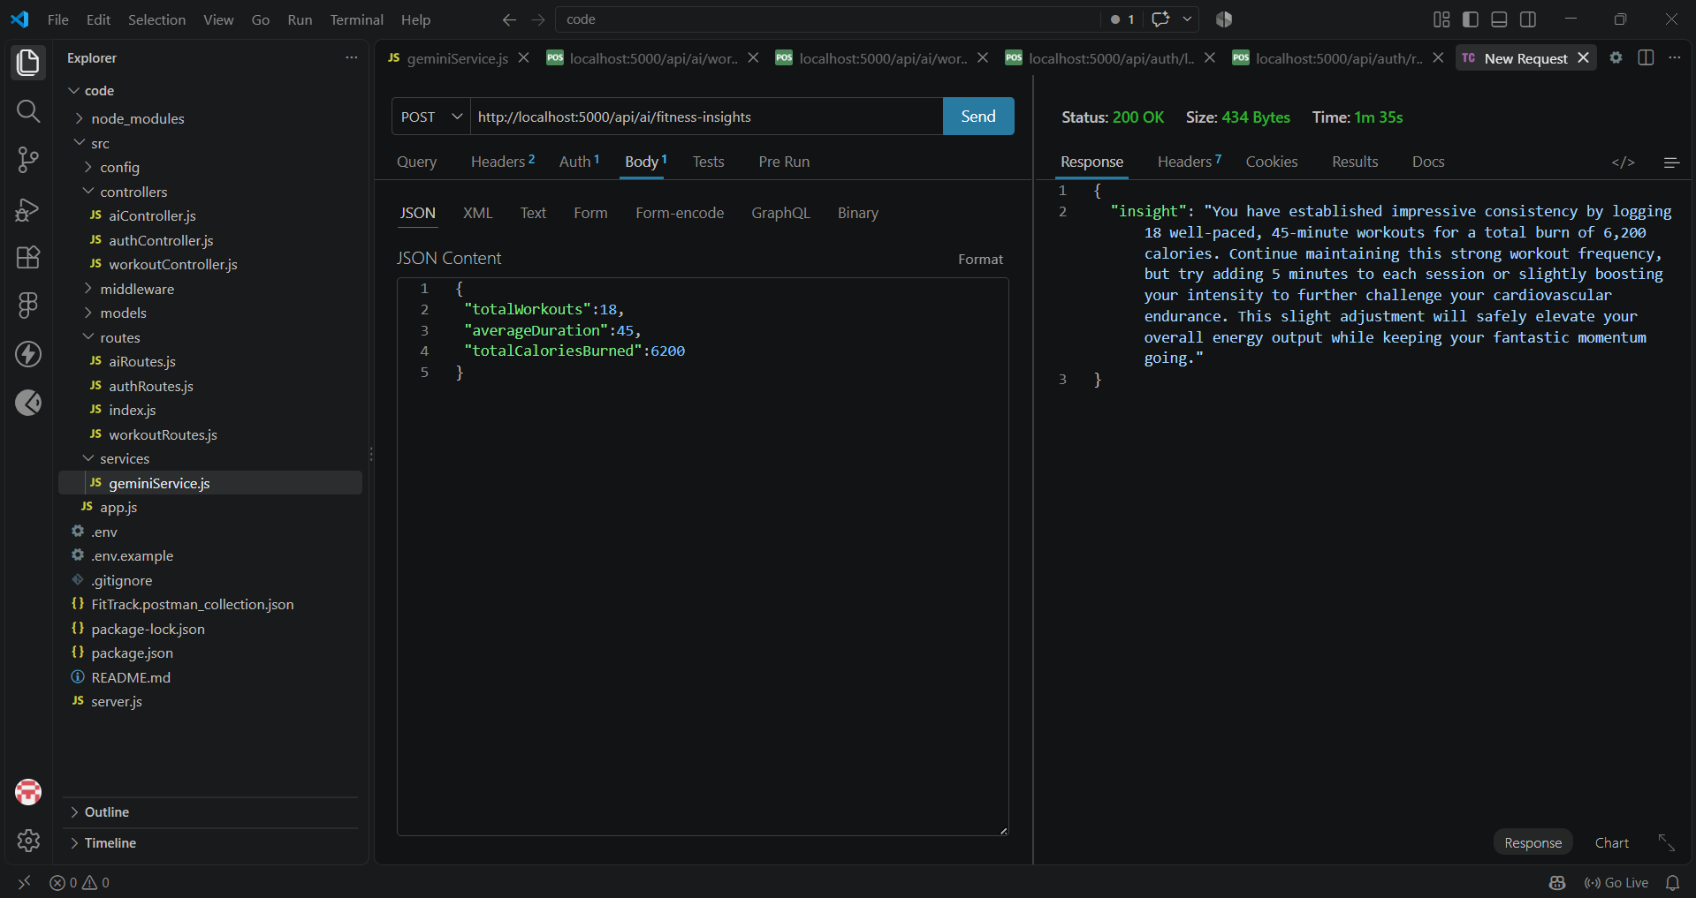
DEMO VEDIO LINK: https://drive.google.com/file/d/1mi-ci75sPedBk_4V2tvNwOuwsgi69Un4/view?usp=drivesdk

